|  |  |  |  |  |  |
| --- | --- | --- | --- | --- | --- |
| Unit 2 – The development of the Cold War 1946-55 | **Road Map - Year 12  *‘The Cold War in Europe 1941-1995’*** | | | | |
| In this unit you will study how the unity of the Grand Alliance shattered and how Europe transitioned from world war to cold war. This unit will include major ‘flash points’ such as; Soviet control of Eastern Europe, the division of Germany, the Berlin Blockade, the formation of NATO and the beginnings of a new arms race. The impact of a change in world leaders will also need to be considered. The aims are as follows:  **LG1**: Knowledge  **LG2**: Application  **LG3**: Skills | Assessments | Grades | | | |
|  |  | | | |
|  |  | | | |
|  |  | | | |
|  |  | | | |
|  |  | | | |
| **Themes** | **Learning Goals/Outcomes/Content** | |  |  |  |
| 1)Key Question–What were the building blocks of Cold War 1946-9? | LG1 – Build your knowledge of the key events that caused tension 1946-49.  LG2 – Apply your knowledge of the key events to analyse their significance in increasing tensions between the Grand Alliance states.  LG3 – Causation and Importance | |  |  |  |
| 2) Key Question– How accurate was Churchill’s assessment that an Iron Curtain had descended across Europe? | LG2 – Apply your knowledge of the Soviet liberation of Eastern Europe to explain why Stalin increased his control after 1947 and the extent it contributed to worsening international relations.  LG3 – Causation, Interpretation and Importance | |  |  |  |
| 3) Key Question– Why could 1947 be seen as a turning point in Cold War relations? | LG1 – Build your knowledge of the Marshall Plan and Truman Doctrine  LG2 – Apply your knowledge of American policy in 1947 to consider the extent it intensified divisions in Europe.  LG3 – Causation, Interpretation and Consequence | |  |  |  |
| 4) Key Question– How did Stalin react to the Truman Doctrine and the Marshall Plan? | LG1 – Build your knowledge of the creation of Cominform and Comecon.  LG2 – Apply your knowledge of Stalin’s reaction to the Marshall Plan to explain the worsening divisions in Europe.  LG3 – Causation, Interpretation and Consequence | |  |  |  |
| 5) Key Question - Why was the German question to become one of the central issues of the Cold War? | LG1 – Build your knowledge of the strategic importance of Germany to both superpowers.  LG2 – Apply your knowledge of Germany’s importance to evaluate the different Cold War Plans for Germany.  LG3 – Importance | |  |  |  |
| 6) Key Question– What were the causes of a divided Germany? | LG1 – Build your knowledge of the causes and consequences of the Berlin Blockade.  LG2 – Apply your knowledge of Cold War tensions to explain the formalised division of Germany in 1949.  LG3 – Causation and Consequence | |  |  |  |
| 7) Key Question - Why was NATO formed and what was its impact on the USSR and superpower relations? | LG1 – Build your knowledge of the creation of NATO and how it led to the formation of the Warsaw Pact.  LG2 – Apply your knowledge of NATO to explain to what extent it contributed to worsening superpower relations or if it simply confirmed existing division.  LG3 – Causation, Importance and Interpretation | |  |  |  |
| 8) Key Question - Why was there Rearmament of Western Europe in 1948-52? | LG1 – Build your knowledge of the reasons for and problems faced by Western rearmament.  LG2 – Apply your knowledge of rearmament to analyse the impact on escalating tensions.  LG3 – Causation, Consequence and Importance | |  |  |  |

**Links:**

This unit draws from earlier work on the clash of ideologies, the long term causes of tension between Communism and the West, as well as the tensions that developed during the course of World War II. You will need to consider how significant events such as the Soviet takeover of Eastern Europe were, when studied in the wider context of international relations. Areas of tension considered in this unit, will be revisited in upcoming units. The problems simply don’t go away! Key history skills such as causation, consequence, importance and interpretation will shape this unit.

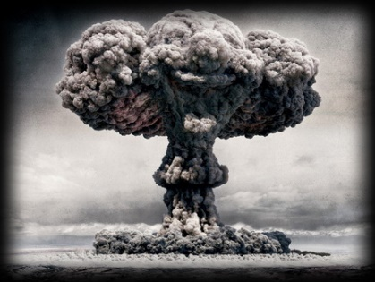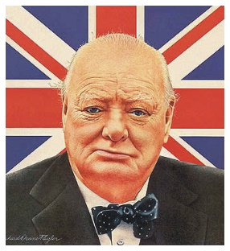[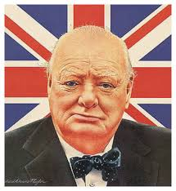](https://www.google.co.uk/url?sa=i&rct=j&q=&esrc=s&source=images&cd=&cad=rja&uact=8&ved=0ahUKEwj0-rWSrp_UAhXBthQKHWENAKYQjRwIBw&url=https://www.emaze.com/@ATWRRCLW/Winston-Churchill&psig=AFQjCNGenLcq3dfIousW0yYyoSO5lFkzbg&ust=1496499743850312)

**Oldbury Wells Humanities Faculty**

***The Cold War in Europe 1941-1995***

**The development of the Cold War 1946-1955**

|  |  |  |  |  |  |
| --- | --- | --- | --- | --- | --- |
|  | **How well have I understood this?** | | | | |
| **Topic** | Not at all | Not well | OK | Well | Very well |
| 1. Iron Curtain speech |  |  |  |  |  |
| 1. Soviet control of Eastern Europe |  |  |  |  |  |
| 1. Truman Doctrine and Marshall Plan |  |  |  |  |  |
| 1. Cominform and Comecon |  |  |  |  |  |
| 1. Berlin blockade and airlift |  |  |  |  |  |
| 1. Creation of East and West Germany |  |  |  |  |  |
| 1. NATO |  |  |  |  |  |
| 1. Warsaw Pact |  |  |  |  |  |
| 1. Atomic weapons and rearmament of Western Europe |  |  |  |  |  |

|  |
| --- |
| **Feedback - WWW/EBI** |
| WWW  EBI |

|  |
| --- |
| **Further ideas for improvement, extra reading etc.** |
|  |