|  |  |  |  |  |  |
| --- | --- | --- | --- | --- | --- |
| Unit 3 – The height of the Cold War 1956-1984 | **Road Map - Year 12  *‘The Cold War in Europe 1941-1995’*** | | | | |
| In this unit you will study how existing divisions intensified and tension literally appeared in concrete with the building of the Berlin Wall. The Arms Race made the Cold War even more deadly and events outside of Europe, such as the Cuban Missile Crisis brought the world to the brink of destruction. This is also an era of lost opportunities; periods of cooperation and Détente seemed to bring hope but all too often those hopes were dashed. The aims are as follows:  **LG1**: Knowledge  **LG2**: Application  **LG3**: Skills | Assessments | Grades | | | |
|  |  | | | |
|  |  | | | |
|  |  | | | |
|  |  | | | |
|  |  | | | |
| **Themes** | **Learning Goals/Outcomes/Content** | |  |  |  |
| 1)Key Question– How was the consolidation of the Eastern Bloc carried out? | LG1 – Build your knowledge of the Soviet response to the rearmament of Western Europe and attempts to impose greater unity on the Eastern Bloc.  LG3 –Consequence | |  |  |  |
| 2) Key Question– What impact did a change of leaders have on the Cold War? | LG1 – Build your knowledge of the key features of the foreign policy of the USA and the USSR  LG2 – Apply your knowledge of the new Cold War Leaders to analyse the impact they would have on superpower relations.  LG3 –Importance | |  |  |  |
| 3) Key Question– What was the significance of the East German Uprising for the future of Germany? | LG1 – Build your knowledge of the causes and consequences of the East German Uprising.  LG2 – Apply your knowledge of the East German Uprising to evaluate it’s significance for the future of Germany.  LG3 – Causation, Consequence and Importance | |  |  |  |
| 4) Key Question– Why did destalinisation cause serious crises within the Soviet bloc? | LG1 – Build your knowledge of destalinisation and the impact it had on Eastern Europe.  LG2 – Apply your knowledge of destalinisation to evaluate which of the super powers benefited most.  LG3 – Causation, Consequence and Importance | |  |  |  |
| 5) Key Question - Why did the Soviet Union provoke a crisis over Berlin 1958-61? | LG1 – Build your knowledge of the causes and consequences of building the Berlin Wall.  LG3 – Causation, Consequence and Importance | |  |  |  |
| 6) Key Question– Why did an arms race develop? | LG1 – Build your knowledge of the causes, along with the key stages in the development of the arms race.  LG2 – Apply your knowledge of the arms race to decide to what extent nuclear weapons made the world safer.  LG3 – Causation, Consequence and Importance | |  |  |  |
| 7) Key Question - How significant was the Space Race? | LG1 – Build your knowledge of the key turning points and consequences of the Space Race.  LG2 – Apply your knowledge to evaluate the significance of the Space Race in comparison to the Arms Race.  LG3 – Consequence and Importance | |  |  |  |
| 8) Key Question - Why was there ‘Détente’ between 1963-69? | LG1 – Build your knowledge of the causes of Détente.  LG2 – Apply your knowledge of Détente to consider to what extent it can be considered a success.  LG3 – Causation, Source analysis and Importance | |  |  |  |
| 9) Key Question - How significant was the Czechoslovakian Crisis of 1968? | LG1 – Build your knowledge of the causes and consequences of the Prague Spring.  LG2 – Apply your knowledge of the Czechoslovakian Revolt to evaluate it’s importance in comparison to the Hungarian Uprising of 1956.  LG3 – Causation, Consequence and Importance | |  |  |  |
| 10) Key Question - To what extent was Ostpolitik a success? | LG1 – Build your knowledge of the key components and interlocking treaties that made up Ostpolitik  LG2 – Apply your knowledge of Ostpolitik to evaluate it’s significance for the FRG.  LG3 –Consequence, Interpretation and Importance | |  |  |  |
| 11) Key Question– Were the Helsinki Accords a triumph for Brezhnev? | LG1 – Build your knowledge of key components of the Helsinki Accords and how they were interpreted.  LG2 – Apply your knowledge of the Helsinki Accords to evaluate how successful they were for the USSR.  LG3 –Importance and Interpretation | |  |  |  |
| 12) Key Question– How far was Détente a success? | LG1 – Build your knowledge of key components of the Helsinki Accords and how they were interpreted.  LG2 – Apply your knowledge of the Helsinki Accords to evaluate how successful they were for the USSR.  LG3 –Importance and Interpretation | |  |  |  |
| 13) Key Question - Why did Détente collapse in 1979? | LG1 – Build your knowledge of the factors that increased international tensions including the Afghanistan War, the rise of Solidarity and a change to the US government.  LG3 – Consequence and Importance | |  |  |  |
| 14) Key Question - What was the impact of New World Leaders on the Cold War in the 1980s? | LG1 – Build your knowledge of the attributes and actions of the new Cold Wars in the 1980s.  LG2 – Apply your knowledge to consider the value of a range of interpretations.  LG3 –Importance and Interpretation | |  |  |  |

**Links:**

This unit draws from earlier work on the division of Europe through the competing aims of the Marshall Plan and Cominform and Comecon, the division of Germany with the creation of the FRG and GDR, as well as the military divisions embodied in the NATO and Warsaw Pact alliances. These divisions will be intensified during this unit and existing tensions will be set in stone – in the case of the Berlin Wall. As the stakes were raised, we will start to consider attempts at cooperation and evaluate what difference they made to the long standing tensions of the Cold War. Key history skills such as causation, consequence, importance and interpretation will shape this unit.

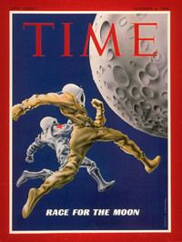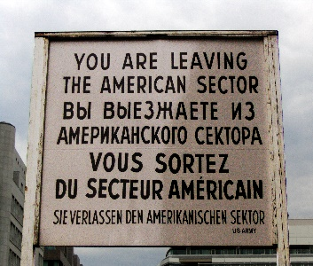

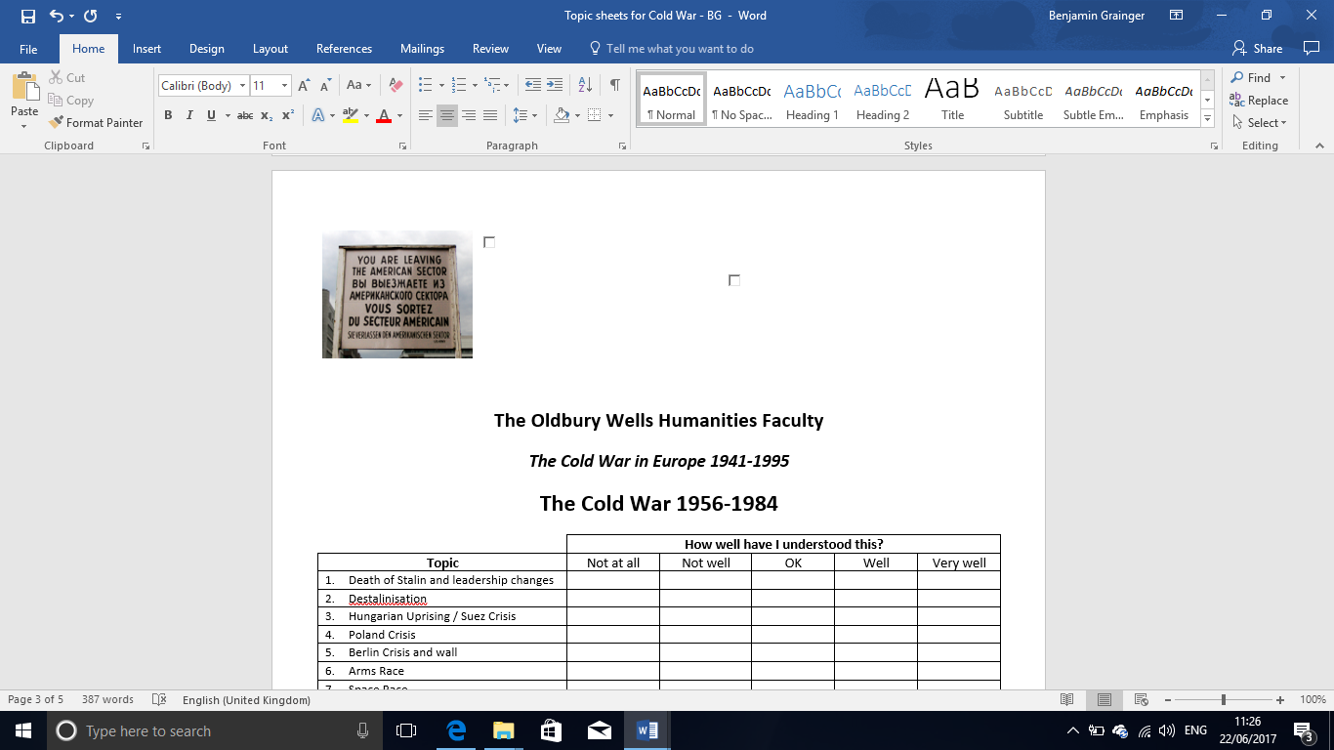



|  |  |  |  |  |  |
| --- | --- | --- | --- | --- | --- |
|  | **How well have I understood this?** | | | | |
| **Topic** | Not at all | Not well | OK | Well | Very well |
| 1. Death of Stalin and leadership changes |  |  |  |  |  |
| 1. Destalinisation |  |  |  |  |  |
| 1. Hungarian Uprising / Suez Crisis |  |  |  |  |  |
| 1. Poland Crisis |  |  |  |  |  |
| 1. Berlin Crisis and wall |  |  |  |  |  |
| 1. Arms Race |  |  |  |  |  |
| 1. Space Race |  |  |  |  |  |
| 1. Detente |  |  |  |  |  |
| 1. Ostpolitik and SALT |  |  |  |  |  |
| 1. Brezhnev doctrine |  |  |  |  |  |
| 1. The impact of the ‘new Cold War’. |  |  |  |  |  |

[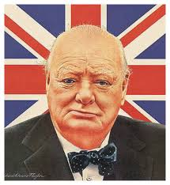](https://www.google.co.uk/url?sa=i&rct=j&q=&esrc=s&source=images&cd=&cad=rja&uact=8&ved=0ahUKEwj0-rWSrp_UAhXBthQKHWENAKYQjRwIBw&url=https://www.emaze.com/@ATWRRCLW/Winston-Churchill&psig=AFQjCNGenLcq3dfIousW0yYyoSO5lFkzbg&ust=1496499743850312)

|  |
| --- |
| **Feedback - WWW/EBI** |
| WWW  EBI |

|  |
| --- |
| **Further ideas for improvement, extra reading etc.** |
|  |