|  |  |  |  |  |  |
| --- | --- | --- | --- | --- | --- |
| **Unit 1 – Religious Change 1547-1558** | **Road Map - Year 12 *‘Religious Change 1547-1558’*** | | | | |
| In this introductory unit you will have the opportunity to study the changes brought about by both monarchs to religion and how far the changes were accepted. The aims are as follows:  **LG1**: Knowledge  **LG2**: Application  **LG3**: Skills | Assessments | Grades | | | |
|  |  | | | |
|  |  | | | |
|  |  | | | |
|  |  | | | |
|  |  | | | |
| **Themes** | **Learning Goals/Outcomes/Content** | |  |  |  |
| 1)Key Question– To what extent did England become Protestant under Somerset? | LG1: to gain a knowledge of the religious changes made under Somerset  LG2: to apply this knowledge to sources to judge the impact of the religious changes  LG3: source work | |  |  |  |
| 2) Key Question – How radical were the religious changes under Northumberland? | LG1: to gain a knowledge of the religious changes made under Northumberland  LG2: to apply this knowledge to sources to judge the impact of the religious changes  LG3: source work | |  |  |  |
| 3) Key Question – To what extent was England a Protestant country by the death of Edward V1 in 1553? | LG1: to gain a knowledge of the religious changes and its impact upon people by 1553  LG2: to apply this knowledge to sources to judge the impact o religious change by 1553  LG3: source work | |  |  |  |
| 4) Key Question – What changes did Mary make to religion and how popular were her policies? | LG1: to understand the religious changes made by Mary  LG2: to apply this knowledge to sources to judge how well received the restoration was  SG3: source work | |  |  |  |
| 5) Key Question– What were the reactions to the persecution and burning of heretics? | LG2: to apply knowledge of the restoration of Catholicism to sources of persecution and burnings  LG 3: source evaluation | |  |  |  |
| 5) Key Question- Evaluating a series of Sources  Attitudes towards the restoration of Catholicism | LG2: Apply knowledge about religious change 1547-1558 to evaluate usefulness of sources  LG3: Source evaluation | |  |  |  |

**Links:**

This first unit focuses on the mid-Tudor crisis 1547-1558, looking at religious changes introduced by Edward and Mary. It will follow the threats to stability and will feed into the unrest and rebellions that took place. Key history skills such as source interpretation and source evaluation skills shape this unit

[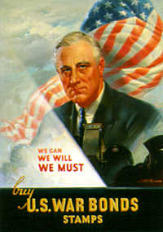](https://www.google.co.uk/url?sa=i&rct=j&q=&esrc=s&source=images&cd=&cad=rja&uact=8&ved=0ahUKEwjJxuL1gZ_UAhUE1hoKHbTeA4kQjRwIBw&url=http://www.columbia.edu/cu/weai/exeas/asian-revolutions/resources/poster-politics.html&psig=AFQjCNF44lbqGpbDfgcAwS-5yD0-mQ_F-g&ust=1496487866832973)[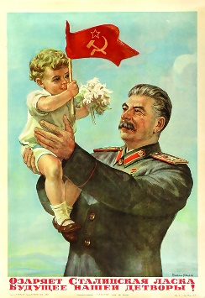](https://www.google.co.uk/url?sa=i&rct=j&q=&esrc=s&source=images&cd=&cad=rja&uact=8&ved=0ahUKEwiz4O-4gZ_UAhXJORoKHU6aAkgQjRwIBw&url=http://www.greanvillepost.com/2015/02/27/the-stalin-question-lives-on/&psig=AFQjCNEV0_rqeh8EdHL9HXGCY1bMBTbfFg&ust=1496487736285659)**Oldbury Wells Humanities Faculty**

***The Cold War in Europe 1941-1995***

**The origins of the Cold War to 1945**

|  |  |  |  |  |  |
| --- | --- | --- | --- | --- | --- |
|  | **How well have I understood this?** | | | | |
| **Topic** | Not at all | Not well | OK | Well | Very well |
| 1. Capitalism Vs Communism |  |  |  |  |  |
| 1. Pre-war tensions from 1917 |  |  |  |  |  |
| 1. The situation in 1941 |  |  |  |  |  |
| 1. War time tensions |  |  |  |  |  |
| 1. Post war aims |  |  |  |  |  |
| 1. Conferences (Tehran,Yalta,Potsdam) |  |  |  |  |  |
| 1. The liberation of Europe |  |  |  |  |  |
| 1. Relations between the Big Three |  |  |  |  |  |

|  |
| --- |
| **Feedback - WWW/EBI** |
| WWW  EBI |

|  |
| --- |
| **Further ideas for improvement, extra reading etc.** |
|  |