The Merchant of Venice background:
Read the following and answer the questions at the end on lined paper

Shylock and Prejudice
- Shylock is a Jew
- Throughout history Jews have frequently been prevented from doing certain businesses or owning land – so few money making options were open to them. They were, however, allowed to lend money and charge interest on it, sometimes called usury. Christians were forbidden the charging of interest by the New Testament and thought of usury as sinful. Therefore many people thought Jews became rich through money lending, creating the impression that they were making money out of other people’s debts / misfortunes.

- In addition many Christians believe that Jews are responsible for Jesus’ death for a number of reasons:

  - There are sections in the bible which show the Jews as having a key role in his death
  - Many of Shakespeare’s audience would have been familiar with ‘Passion Plays’, as in The Passion of the Christ. These were violent depictions of Jesus’ crucifixion that blamed the Jews for his death
  - Edward I expelled all Jews from England in 1290. Jews were not officially allowed back into England until 1655, a date considerably after Shakespeare’s death. However, Jews were allowed to stay if they pretended to be Christian
  - Shakespeare’s audience would definitely have been aware that Queen Elizabeth’s doctor, was executed for trying to poison her in 1594
  - Many of Shakespeare’s audience would also have seen Marlowe’s play The Jew of Malta, performed in about 1578, which is about a unrepentantly evil Jew called Barabas

- Only in 1965 did the Vatican officially declare that Jews were not responsible for Jesus’ death

- However, in Shakespeare’s time, Jews were not really people to fear in England; they could be held up as ready-made villains in much the same way that Hollywood movies used Russians during the height of the Cold War.

Christians & Jews
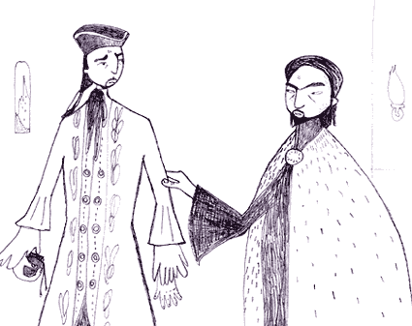

Money-lenders preying on Christian debtors
Although Jesus Christ himself was born a Jew, there have been battles between Jews and Christians for 2000 years. Many Jews moved away from the area where they lived to escape persecution, taking their customs and cultures with them. Through their hard work and consequent success in business, Jews were often resented in their new homes, especially in Christian countries.
In England, when Shakespeare was writing, Jews had been banished for the past 300 years. Shakespeare's audience would not have known any Jews; their knowledge of Jews would have been based solely on rumour and prejudice. They would have enjoyed the verbal insults and racist jokes against Shylock, and would probably not have questioned the treatment Shylock receives as we do today.

Venice:
Shakespeare set his play here because it is a romantic and foreign location. Despite our concern with Shylock’s villainy it is actually a love story and is viewed as one of Shakespeare’s works of comedy, although a Shakespearean comedy doesn’t actually have to be funny; it just means a play with a happy ending. As such, setting the play in Venice would have allowed the audience to suspend their beliefs about reality in order to facilitate the telling of the romantic story.
Given the legal absence of Jews from England, it was also a place where the ‘bogey man’ Jew, Shylock could live. Additionally, Venice is famous for trading and a likely setting for rich merchants.
In the Elizabethan imagination, Venice stood for the fabulous wealth and luxury associated with the new world of merchant trading to which England had only belatedly gained access. But, more dangerously, Venice also represented the potential corruptions that happen when trading for profit. Shakespeare's play shows how this can be ruthless and nasty in its competition. Shakespeare places this all onto the alien figure of Shylock - the Jew whose money-lending fuels the engines of trade.

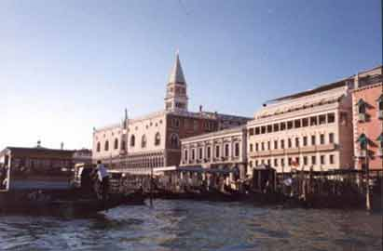
The Doge's Palace, Venice

Venice was famous as an important Mediterranean trading centre for goods from the Far East. Silks, spices, jewels and other expensive items were bought and sold there - including slaves. It had the reputation of being full of fashion, culture and sophistication. It would have been a very exotic location for an Elizabethan audience.
Venice was run by a Duke, or Doge, who ruled with an iron fist. All Venetians were encouraged to do whatever they had to for the security of the state, even spying on other ports. People who were seen to have committed a crime against the state were often killed without trial and their bodies were left in the street to serve as a warning to others.
Because of Venice's position as a centre for trade, it was full of people of many different nationalities, religions and races. The Christian leaders were keen to put an end to the activities of the Jews, and so created one of the first Jewish ghettos, forcing the Jews to live in a particular area.

Characteristics of Shakespearean Comedy
It is important to note that the term "comedy" didn't quite have the same meaning to Elizabethan audiences as it does today. While there is certainly quite a bit of humour to be found in Shakespeare's comedies, "comedy" generally referred to a light-hearted play with a happy ending, as opposed to his more dramatic tragedies and history plays.
Shakespeare's Comedies
Some of Shakespeare’s comedies are truly funny from beginning to end, while others, like The Merchant of Venice, have a very serious tone or strong dramatic moments. In all of these works, you'll find the following elements:
- Young lovers struggling to overcome obstacles: These obstacles are typically brought about by the elders in the play, often parents or guardians of the lovers. Various circumstances cause the lovers to be kept apart and they must find their way back together in the end.

- Mistaken Identity: Mistaken identity was one of Shakespeare's favourite and most-used plot devices. Gender mix-ups were also quite popular. Shakespeare quite often had characters masquerading as the opposite sex. During Shakespeare's lifetime, men played all the roles in a play, which added another dimension to the comedy.

- Clever plot twists: Shakespearean comedy always involves multiple plot lines, cleverly intertwined to keep the audience guessing. These unexpected twists are always straightened out in a happy ending.

- Use of puns: Shakespeare’s comedies are filled with puns and witty language games. Sometimes silly, sometimes rude, always clever, his plays on words are a key feature of all his works.

- Happy endings: All Shakespearean comedies end happily. Most often, this happy ending involves marriage or pending marriage. Love always wins out in the end.

Answer the following:

- Define Shakespearean comedy.

- What do we expect to find in Shakespearean comedies?

- Summarise the kinds of views towards Jewish people that could be found in 1600.

- Describe a range of views about Venice that might be held by a well-educated member of Shakespeare’s audience.

- Write three PEA (point, evidence, analysis) paragraphs to answer: To what extent do you feel sympathy for Shylock during Act 1 scene 3 of The Merchant of Venice?

Challenge: write a PEA (point, evidence, analysis) paragraph to answer: How is Antonio presented in Act 1 scene 3 of The Merchant of Venice?

