Christian Beliefs - Revision Questions

- Approximately, what percentage of the world’s population say they are Christian?

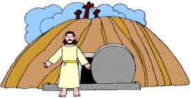
- How and when was Jesus killed?

- What happened to Jesus three days after his death? (Use the proper term).

- In 1054 the Great Schism happened. Explain what this was.

- Who was Martin Luther and what was his connection to the Reformation in the 16th century?

- Which person of the Holy Trinity is described as the unseen power of God at work in the world, an inspiration and guide?

- Which person of the Holy Trinity is described as God incarnate?

- Which person of the Holy Trinity is described as the creator of the earth and everything on it?

- In John’s gospel it is said that ‘the Word’ was present at creation. Who, is it thought, that this refers to?

- Jesus is referred to as Christ. What does this word mean and what Hebrew term does it link to?

- What did Jewish people believe the Messiah’s purpose was?

- Why do Christians believe Jesus is the Messiah?

- What does Jesus’ crucifixion mean for Christians today?

- Give three reasons why some people would doubt Jesus’ resurrection.

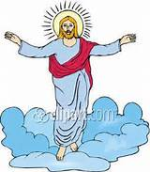
- Who saw Jesus after his resurrection?

- What happened to Jesus 40 days after his resurrection?

- Give three reasons why the resurrection of Jesus is important for Christians today.

- What does the ascension mean for Christians today?

- Give two beliefs Christians have about what happens when a person who has died is resurrected.

- What does the Apostle’s Creed suggest about life after death?

- How do Christians believe they will receive a favourable afterlife?

- Which Christian denomination believes in purgatory? Briefly explain this belief.

- Give three examples of sins in Christianity that are not crimes in the UK.

- Salvation means to be saved. Give two ways in which Christians believe salvation can come about.

- Original sin was committed by Adam and Eve when they disobeyed God. How do Christians believe Jesus makes up for this sin?

- Atonement means restoring the relationship between people and God. How did Jesus’ death help restore this relationship?

