GCSE Required Practicals
Making salts

Required practical activity | Apparatus and techniques
Preparation of a pure, dry sample of a soluble salt from an insoluble oxide or carbonate, using a Bunsen burner to heat dilute acid and a water bath or electric heater to evaporate the solution. | AT 2, AT 3, AT 4, AT 6

Preparation of pure dry copper sulfate crystals

You will react an acid and an insoluble base to prepare an aqueous solution of a salt. The unreacted base from the reaction will need to be filtered. You will evaporate the filtrate to leave a concentrated solution of the salt, which will crystallise as it cools and evaporates further. When dry the crystals will have a high purity.

Learning outcomes
- Using a solid reactant helps us identify when all the acid has been used up/neutralised

- Excess solid reactant can be filtered to remove it

- Boiling off some water helps concentrate a solution so crystals can form

- Identify the main hazards and how to minimise the risk

You are provided with the following:
- 40 cm³ 1.0 M dilute sulfuric acid
- copper (II) oxide powder
- spatula
- glass rod
- 100 cm³ beaker
- Bunsen burner
- tripod
- gauze
- heatproof mat
- filter funnel and paper
- clamp stand
- conical flask
- 250 cm³ beaker
- evaporating basin
- crystallising dish

Risk assessment: Safety goggles must be worn throughout.
Method

- Measure 40 cm³ sulfuric acid into the 100 cm³ beaker.
The volume does not need to be very accurate, so you can use the graduations on the beaker.

- Set up the tripod, gauze and heatproof mat. Heat the acid gently using the Bunsen burner until it is almost boiling. Turn off the Bunsen burner.

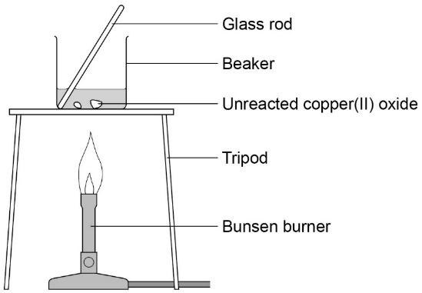

- Use the spatula to add small amounts of copper (II) oxide powder. Stir with the glass rod.
Continue to add copper (II) oxide if it keeps disappearing when stirred. When the
copper (II) oxide disappears the solution is clear blue.

- Stop adding the copper (II) oxide when some of it remains after stirring.
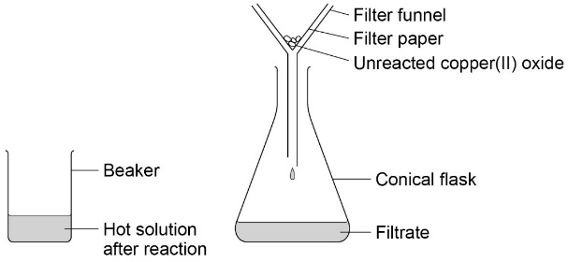
Allow apparatus to cool completely.

- Set up the filter funnel and paper over the conical flask. Use the clamp stand to hold the funnel.
Filter the contents of the beaker from step 3.
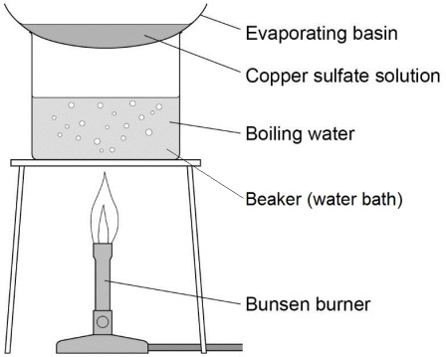
- When filtration is complete, pour the contents of the conical flask into the evaporating basin.
Evaporate this gently using a water bath (250 cm³ beaker with boiling water) on the tripod and gauze (see diagram). Stop heating once crystals start to form.

- Transfer the remaining solution to the crystallising dish. Leave this in a cool place for at least 24 hours.

- Remove the crystals from the concentrated solution with a spatula. Gently pat the crystals dry between two pieces of filter paper. These are pure dry crystals of copper (II) sulfate.
Neutralisation (Higher Tier)
Check up:
- Look at the learning outcomes. Highlight the text where each learning outcome is achieved during in the experiment.
- Write a word and symbol equation for this reaction.

- Think about safety. What hazards are there in this experiment? List each and describe how you can make yourself safe.

Required practical activity | Apparatus and techniques
Higher Tier only  Determination of the concentration of one of the solutions in mol/dm3 and g/dm3 from the reacting volumes and the known concentration of the other solution. | AT 1, AT 8

Investigation to find the concentration of a dilute sulfuric acid solution using a sodium hydroxide solution of known concentration

You will find the volume of dilute sulfuric acid needed to neutralise 25 cm³ of 0.5 mol/dm³ sodium hydroxide solution. Observing the colour change in an acid-base indicator is used to do this.

The sulfuric acid has an unknown concentration. You also calculate the concentration of the sulfuric acid used in mol/dm³ and g/dm³.

Learning outcomes
- Titrations accurately find the concentration of unknown substances

- One drop is enough to change the pH by a large amount, so the end point is very clear

- To read a burette accurately, eyes must be level with the meniscus.

- Understand when sufficient precise measurements have been taken to give valid results

Risk assessment- Safety goggles should be worn throughout.
You are provided with the following:
- 25 cm³ volumetric pipette and pipette filler
- burette
- small funnel
- clamp stand
- 250 cm³ conical flask
- white tile
- dilute sulfuric acid of unknown concentration
- 0.1 mol/dm³ sodium hydroxide solution
- methyl orange indicator.

Method
- Use the pipette and pipette filler to put exactly
25 cm³ sodium hydroxide solution into the conical
flask. Your teacher will show you how to do this.
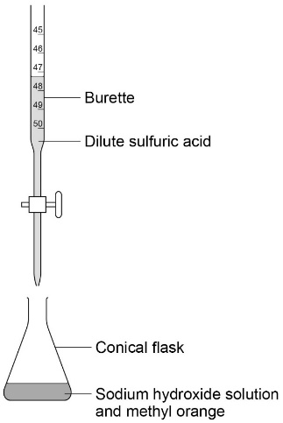
Stand the flask on a white tile.

- Clamp the burette vertically in the clamp stand
about halfway up its length.
There should be just enough room underneath for
the conical flask and tile.

- Close the burette tap. Use the small funnel to carefully fill the burette with dilute sulfuric acid.
You should do this at a low level so that you are not pouring acid from above head height. For
example put the clamp stand temporarily on a lab stool or the floor.
- Put about 5 drops of methyl orange indicator into the conical flask. Swirl to mix and place under the
burette with the tile.
- Carefully open the tap so that sulfuric acid flows into the flask at a slow rate.
Constantly swirl the flask when adding the acid. Look for a colour change from yellow to red in the indicator.
- There will be signs that the colour change is close to being permanent. When this happens use the tap to slow the drops down.
You need be able to shut the tap immediately after a single drop of acid causes the colour to become permanently red.
- Read the burette scale carefully and record the volume of acid you added. You can use a table such as the one below.

Volume of dilute sulfuric acid needed to neutralise
25cm³ sodium hydroxide solution (cm³)
 | Rough | Trial 1 | Trial 2 | Trial 3
Final Volume cm³
Initial Volume
cm³
Volume added cm³

- Repeat steps 1‒7 twice more and record the results in the table.

- Calculate the mean value for the volume of acid needed to neutralise 25 cm³ of the sodium hydroxide solution. Record this value in the final space in the table.
Use your mean result to calculate the concentration of the acid in mol/dm³ and g/dm³ using the following calculation steps.

Check up:
- Look at the learning outcomes. Highlight the text where each learning outcome is achieved during in the experiment.
- Write a word and symbol equation for this reaction.

- What equations do you need to use to calculate the concentration in mol dm⁻³ and g dm⁻³

- What is the uncertainty in reading the volume from a burette?

- How does this method minimise the uncertainty?

- Do your results show repeatability? If so, why? If not, what should you do to make them repeatable?

Neutralisation (FoundationTier)
Required practical activity | Apparatus and techniques
Determination of the reacting volumes of solutions of a strong acid and a strong alkali by titration. | AT 1, AT 8

Investigation to find the volume of dilute sulfuric acid needed to neutralise a known volume of sodium hydroxide solution

You will find the volume of dilute sulfuric acid needed to neutralise 25 cm³ of sodium hydroxide solution. Observing the colour change in an acid-base indicator is used to do this.

Learning outcomes
- Titrations accurately find the volume of acids needed to neutralise an alkali

- One drop is enough to change the pH by a large amount, so the end point is very clear

- To read a burette accurately, eyes must be level with the meniscus.

- Understand when sufficient precise measurements have been taken to give valid results

Risk assessment- Safety goggles should be worn throughout.
You are provided with the following:
- 25 cm³ volumetric pipette and pipette filler
- burette
- small funnel
- clamp stand
- 250 cm³ conical flask
- white tile
- dilute sulfuric acid of unknown concentration
- 0.1 mol/dm³ sodium hydroxide solution
- methyl orange indicator.

Method
- Use the pipette and pipette filler to put exactly
25 cm³ sodium hydroxide solution into the conical
flask. Your teacher will show you how to do this.
Stand the flask on a white tile.

- Clamp the burette vertically in the clamp stand
about halfway up its length.
There should be just enough room underneath for
the conical flask and tile.

12. Close the burette tap. Use the small funnel to carefully fill the burette
with dilute sulfuric acid to the 0 cm³ line.
You should do this at a low level so that you are not pouring acid from above head height. For example put the clamp stand temporarily on a lab stool or the floor.

- Put about 5 drops of methyl orange indicator into the conical flask. Swirl to mix and place under the
burette with the tile.
- Carefully open the tap so that sulfuric acid flows into the flask at a slow rate.
Constantly swirl the flask when adding the acid. Look for a colour change from yellow to red in the indicator.
- There will be signs that the colour change is close to being permanent. When this happens use the tap to slow the drops down.
You need be able to shut the tap immediately after a single drop of acid causes the colour to become permanently red.
- Read the burette scale carefully and record the volume of acid you added. You can use a table such as the one below.

Volume of dilute sulfuric acid needed to neutralise
25cm³ sodium hydroxide solution (cm³)
Trial 1 | Trial 2 | Trial 3 | Mean

- Repeat steps 1‒7 twice more and record the results in the table.

18. Calculate the mean value for the volume of acid needed to neutralise 25 cm³ of the sodium hydroxide solution. Record this value in the final space in the table.

Check up:
- Look at the learning outcomes. Highlight the text where each learning outcome is achieved during in the experiment.
- Write a word equation for this reaction.

- In another experiment, with the same acid, the volume of acid needed to neutralise the alkali was larger. What does this tell you?

- Do your results show repeatability? If so, why? If not, what should you do to make them repeatable?

Electrolysis
Required practical activity | Apparatus and techniques
Investigate what happens when aqueous solutions are electrolysed using inert electrodes. This should be an investigation involving developing a hypothesis. | AT 3, AT 7, AT 8
Investigating the elements formed at each electrode when different salt solutions are electrolysed
You will use a low voltage power supply and carbon rod electrodes to pass a current through four different salt solutions. You will identify the element formed at the positive and negative electrode in each case.
Learning outcomes
- Understand that ionic solutions can conduct electricity

- Positive ions are reduced at the negative (cathode) electrode

- Negative ions are oxidised at the positive (anode) electrode

- Blue litmus turns red in acid and then bleached when chlorine is present.

- Decide whether or not your observations supports the theory of ionic bonding in compounds.

Risk assessment: Safety goggles.
You are provided with the following:
- copper (II) chloride solution
- copper (II) sulfate solution
- sodium chloride solution
- sodium sulfate solution
- 100 cm³ beaker
- petri dish lid
- two carbon rod electrodes
- two crocodile/4 mm plug leads
- low voltage power supply
- blue litmus paper
- tweezers.

Method
- Pour copper (II) chloride solution into the beaker to about 50 cm³.
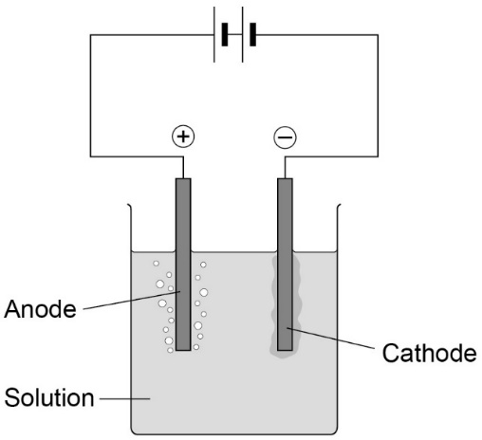
- Add the lid and insert carbon rods through the holes. The rods must not touch each other.
Attach crocodile leads to the rods. Connect the rods to the dc (red and black) terminals of a low voltage power supply.

- Select 4 V on the power supply and switch on.

- Look at both electrodes. Is there bubbling at neither, one or both electrodes?

- Use tweezers to hold a piece of blue litmus paper in the solution next to the positive electrode (the one connected to the red terminal). You will need to lift the lid temporarily to do this.

Solution | Positive electrode (anode) |  | Negative electrode (cathode)
 | Observations | Element formed | Observations | Element formed
Copper (II) chloride
Copper (II) sulfate
Sodium
chloride
Sodium
sulfate

- After no more than five minutes, switch off the power supply.
Examine the negative electrode (the one connected to the black terminal). Is there evidence of a metal coating on it? What could it be?
Check up:
- Look at the learning outcomes. Highlight the text where each learning outcome is achieved during in the experiment.
- Write a ½ equation for each reaction at each electrode.

- Explain why your observations support the idea that ionic compounds are made of positive and negative ions, and that the ions are free to move when in solution.
Temperature changes
Required practical activity | Apparatus and techniques
Investigate the variables that affect temperature changes in reacting solutions such as, eg acid plus metals, acid plus carbonates, neutralisations, displacement of metals. | AT 1, AT 3, AT 5, AT 6
Investigation of the temperature changes which take place when an acid is neutralised by an alkali
You will monitor the temperature rise as small volumes of sodium hydroxide solution are added to dilute hydrochloric acid. The acid will be contained in an insulated cup.
Plot a graph of your results. Determine how much sodium hydroxide was needed to fully react with the acid.
Learning outcomes
- Exothermic reactions give out heat to the surroundings

- To measure energy released or taken in we have to use change in temperature

- Drawing a graph with lines of best fit, helps us understand the chemical reaction

- It is important to reduce heat loss during these measurements so appropriate apparatus has to be chosen to reduce heat loss.

Risk assessment: Safety goggles.
You are provided with the following:
- 2 M dilute hydrochloric acid
- 2 M sodium hydroxide solution
- expanded polystyrene cup and lid
- 250 cm³ beaker
- 10 cm³ measuring cylinder
- 50 cm³ measuring cylinder
- thermometer.

Method
- Use the 50 cm³ measuring cylinder to put 30 cm³ dilute hydrochloric acid into the
polystyrene cup.
- Stand the cup inside the beaker. This will make it more stable.
- Use the thermometer to measure the temperature of the acid. Record it in the first blank column of the table such as the one below.

- Put 5 cm³ sodium hydroxide solution into the 10 cm³ measuring cylinder.

- Pour the sodium hydroxide into the cup. Fit the lid and gently stir the solution with the thermometer through the hole.
When the reading on the thermometer stops changing, write the temperature in the next space in the table.
- Repeat steps 4 and 5 to add further 5 cm³ amounts of sodium hydroxide to the cup. A total of 40 cm³ needs to be added.
The last few additions should produce a temperature fall rather than a rise.
- Repeat steps 1–6 and record the results in the second blank column of the table.

- Calculate the mean maximum temperature reached for each of the sodium hydroxide volumes. Record these means in the third blank column.

Total volume of sodium hydroxide  added in cm³ | Maximum temperature in ºC
 | First trial | Second trial | Mean
0
5
10
15
20
25
30
35
40

Draw two straight lines of best fit:
- one through the points which are increasing
- one through the points which are decreasing.

Ensure the two lines are extended so they cross each other.

- Use the graph to estimate how much sodium hydroxide solution was needed to neutralise
25 cm³ dilute hydrochloric acid.

Check up:
- Look at the learning outcomes. Highlight the text where each learning outcome is achieved during in the experiment.
- Write a word equation for this reaction.

- Why does the temperature start to drop?

- What apparatus has been chosen to reduce heat loss?

- How could the apparatus or procedure be improved to make the results more reliable?

Rates of reaction
Required practical activity | Apparatus and techniques
Investigate how changes in concentration affect the rates of reactions by a method involving measuring the volume of a gas produced and a method involving a change in colour or turbidity.  This should be an investigation involving developing a hypothesis. | AT 1, AT 3, AT 5, AT 6

Investigation into how the concentration of a solution affects the rate of a chemical reaction
Activity 1: Observing colour change
You will react sodium thiosulfate with hydrochloric acid. You will then find out how the rate of reaction changes as the thiosulfate solution becomes more dilute.
Activity 2: Measuring the volume of gas produced
You will react magnesium ribbon and hydrochloric acid. You will then find out how the rate of reaction is affected by the concentration of the acid.

Learning outcomes
- How does concentration affect rate of reaction?

- Time to complete a reaction can be found using an obvious end point

- How to dilute solutions to change the concentration

- How to calculate a mean and discount anomalies
You are provided with the following:
- 40 g/dm³ sodium thiosulfate solution
- 2.0 M dilute hydrochloric acid
- 10 cm³ measuring cylinder
- 100 cm³ measuring cylinder
- 100 cm³ conical flask
- printed black paper cross
- stopclock.

Risk assessment: Safety goggles.
Method
Activity 1: Observing colour change
- Use a measuring cylinder to put 10 cm³ sodium thiosulfate solution into the conical flask.
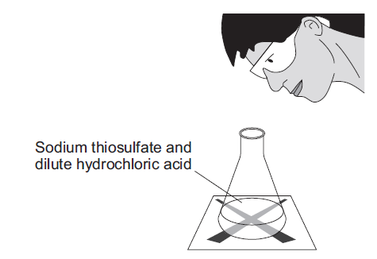
Use the measuring cylinder to then add 40 cm³ water. This dilutes the sodium thiosulfate solution to a concentration of 8 g/dm³.
Put the conical flask on the black cross.
- Put 10 cm³ of dilute hydrochloric acid into the 10 cm³ measuring cylinder.
- Put this acid into the flask. At the same time swirl the flask gently and start the stopclock.
- Look down through the top of the flask. Stop the clock when you can no longer see the cross.
Take care to avoid breathing in any sulfur dioxide fumes.
- Write the time it takes for the cross to disappear in the first blank column of the table such as the one below. Record the time in seconds.
You will need to multiply any minutes by 60 and then add the extra seconds.
Concentration of sodium thiosulfate in g/dm³ | Time taken for cross to disappear in seconds
 | First trial | Second trial | Third trial | Mean (remember to discount anomalies)
8
16
24
32
40

- Repeat steps 1‒5 four times, but in step 1 use:
- 20 cm³ sodium thiosulfate + 30 cm³ water (concentration 16 g/dm³)
- 30 cm³ sodium thiosulfate + 20 cm³ water (concentration 24 g/dm³)
- 40 cm³ sodium thiosulfate + 10 cm³ water (concentration 32 g/dm³)
- 50 cm³ sodium thiosulfate + no water (concentration 40 g/dm³)
- Then repeat the whole investigation (steps 1–5) twice more.
- Calculate the mean time for each of the sodium thiosulfate concentrations. Leave out anomalous values from your calculations.
- Plot a graph with:
- ‘mean time taken for cross to disappear in seconds’ on the y-axis
- ‘Sodium thiosulfate concentration in g/dm³’ on the x-axis

Draw a smooth curved line of best fit.
What can you say about the effect of the independent variable (concentration) on the dependent variable (time taken for the cross to disappear)? What were your control variables?

Check up:
- Look at the learning outcomes. Highlight the text where each learning outcome is achieved during in the experiment.

- Did you identify any anomalies? How can you tell?

- How can checking the results with your classmates, help you decide if the results are reproducible?

Activity 2: Measuring the volume of gas produced
Learning outcomes
- How does concentration affect rate of reaction?

- Discover how the rate changes during the reaction

- How to dilute solutions to change the concentration

- How to calculate a mean and discount anomalies
Risk assessment: Safety goggles.
You are provided with the following:
- safety goggles
- conical flask (100 cm³)
- single-holed rubber bung and delivery tube to fit conical flask
- trough or plastic washing-up bowl
- two measuring cylinders (100 cm³)
- clamp stand, boss and clamp
- stop clock
- graph paper
- magnesium ribbon cut into 3 cm lengths
- dilute hydrochloric acid, (2.0 M, and 1.0 M).

Method
- Measure 50 cm³ of 2.0 M hydrochloric acid using one of the measuring cylinders. Pour the acid into the 100 cm³ conical flask.

- Set up the apparatus as shown in the diagram.
Half fill the trough or bowl with water.
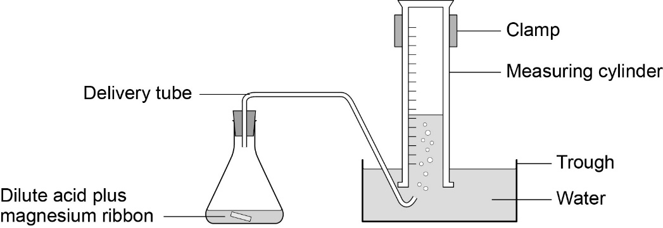

- Fill the other measuring cylinder with water. Make sure it stays filled with water when you turn it upside down.
- When you are ready, add a 3 cm strip of magnesium ribbon to the flask, put the bung back into the flask as quickly as you can, and start the stopclock.

- Record the volume of hydrogen gas given off at suitable intervals (eg 10 seconds) in a table such as the one below.
Continue timing until no more gas appears to be given off.

Time in seconds | Volume of gas produced for 2.0 M hydrochloric acid in cm³(series 1) | Volume of gas produced for 1.0 M hydrochloric acid in cm³ (series 2) | Volume of gas produced for 0.5 M hydrochloric acid in cm³ (series 3)
10
20
30
40
50
60
70
80
90
100

- Repeat steps 1-5 using 1.0 M hydrochloric acid.

- Plot a graph with:

Draw a smooth curved line of best fit.
- Compare your results with the data collected in Activity 1.

- Use kinetic theory to explain your findings.

Check up:
- Look at the learning outcomes. Highlight the text where each learning outcome is achieved during in the experiment.

- Did you identify any anomalies? How can you tell?

- Calculate the average rate at 60s for each concentration?

- Calculate the rate at 20seconds for 1.0M acid (remember tangent to the curve)

Chromatography
Required practical activity | Apparatus and techniques
Investigate how paper chromatography can be used to separate and tell the difference between coloured substances. Students should calculate Rf values. | AT 1, AT 4

Investigation into the use of paper chromatography to separate and identify a mixture of food colouring.
You will use paper chromatography to separate the different colours present in an unknown mixture of food colourings. You will then measure the distance travelled by each colour and the solvents to calculate R_{f} values.
Learning outcomes
- Chromatography can separate a mixture

- Rf values are constant for the same colour and can help identify the food colouring

- Chromatography needs a mobile solvent and a stationary paper phase to work

- Use an appropriate number of significant figures when quoting Rf values

You are provided with the following:
- 250 cm³ beaker
- glass rod
- a rectangle of chromatography paper
- four known food colourings labelled A-D
- an unknown mixture of food colourings labelled U
- glass capillary tubes.

- Risk assessment: Safety goggles.

Method

- Use a ruler to draw a horizontal pencil line 2 cm from a short edge of the chromatography paper.
Mark five pencil spots at equal intervals across the line. Keep at least 1 cm away from each end.
- Use a glass capillary tube to put a small spot of each of the known colourings on four of the pencil spots. Then use the glass capillary tube to put a small spot of the unknown mixture on the 5th pencil spot.
Try to make sure each spot is no more than 5 mm in diameter.
Label each spot in pencil.
- Pour water into the beaker to a depth of no more than 1 cm.

- Tape the edge of the chromatography paper to the glass rod. The paper needs to be taped at the end furthest from the spots.
Rest the rod on the top edge of the beaker. The bottom edge of the paper should dip into the water.
Ensure that the:
- pencil line is above the water surface sides of the paper do not touch the beaker wall.

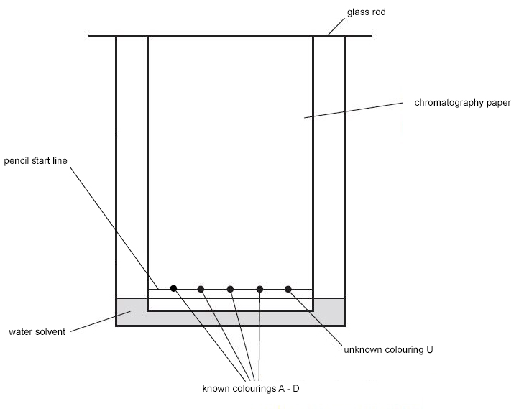
- Wait for the water solvent to travel at least three quarters of the way up the paper. Do not disturb the beaker during this time.
Carefully remove the paper. Draw another pencil line on the dry part of the paper as close to the wet edge as possible.

- Hang the paper up to dry thoroughly.
Measure the distance in mm between the two pencil lines. This is the distance travelled by the water solvent.
Measure and record the same distance for each food colouring in the table below.

Food colouring | Distance travelled in mm |  | Rf value
 | Solvent | Spot
A
B
C
D
U (spot 1)
U(spot 2)

- For each of the four known colours, measure the distance in mm from the bottom line to the centre of each spot. Write each measurement in the table.

- Use the following equation to calculate the R_{f} value for each of the known colours.

$${\text{R}}_{\text{f}}\text{ = }\frac{\text{distance}\text{ moved by substance}}{\text{distance moved by solvent}}$$

Write the calculated values in the table.

- Match the spots in mixture U with those from A–D. Use the colour and distance travelled to help you.
Which of colourings A–D are in mixture U?
Are there any other colourings in mixture U which do not match A–D?

Check up:
- Look at the learning outcomes. Highlight the text where each learning outcome is achieved during in the experiment.

- How can you find out how many different colours are in a food dye?

- How can you identify the exact food colouring in the dye?

- How can you check your results are repeatable?

- How can you use the results from your class mates to make sure your results are reproducible?

- Consider the precision of your ruler, how many significant figures should you quote your Rf values?

Identifying Ions
Required practical activity | Apparatus and techniques
Use of chemical tests to identify the ions in unknown single ionic compounds covering the ions from sections 4.8.3.1 to 4.8.3.5. | AT 1, AT 8

Identify the ions in a single ionic compound using chemical tests
You will analyse a range of known ionic compounds.
The methods you will use are:
- flame testing
- addition of acids
- addition of barium chloride
- addition of silver nitrate.
You will then apply the knowledge you gain to identify the ions in an unknown compound.
Learning outcomes
- Cations can be identified from flame tests and reaction with sodium hydroxide to form precipitates

- Anions can be identified using a variety of specific chemical reactions

You are provided with the following:
- Bunsen burner
- test tubes and test tube rack
- teat pipette
- nichrome wire mounted in handle
- limewater
- 0.4 M dilute hydrochloric acid
- 0.1 M barium chloride solution
- 0.4 M dilute nitric acid
- 0.05 M silver nitrate solution
- known labelled solutions: chlorides of lithium, sodium, potassium, calcium and copper
- known labelled solutions: sodium salts containing carbonate, sulfate, chloride, bromide and iodide
- salt solution labelled ‘unknown’.

Risk assessment: Safety goggles.
Method: Cations (metal positive ions)
Flame Tests
- Pour around 1 cm depth of each of the labelled chloride solutions into five test tubes in the rack.
- Dip the nichrome wire into the first solution. Then hold the tip of the wire in a blue Bunsen burner flame.
- Record your observation in Table 1 (at end of this worksheet).
- Clean the wire carefully.
- Repeat steps 2‒4 for each of the other four solutions.
Possible flame colours are:
- green
- crimson
- lilac
- yellow
- orange-red.

- Empty and clean the test tubes.

Table 1
Metal ion | Lithium Li⁺ | Sodium Na⁺ | Potassium K⁺ | Calcium Ca²⁺ | Copper Cu²⁺
Flame colour | Crimson | yellow | Lilac | Orange-red | Green

Hydroxide test
- Pour around 1 cm depth of each of the labelled chloride solutions into five test tubes in the rack.
- Add a few drops of sodium hydroxide solution.
- Record your observations in Table 2.

Table 2
Metal ion | Calcium Ca²⁺ | Magnesium Mg²⁺ | Aluminium Al³⁺ | Fe (II) Fe²⁺ | Fe (III) Fe³⁺ | Copper Cu²⁺
ppt colour with NaOH | White ppt | White ppt | White ppt which then dissolves in xs. | Green ppt | Brown ppt | Blue ppt

Method: Anions (non-metal negative ions)
Carbonate test
- Pour around 1 cm depth of each of the labelled sodium solutions into five test tubes in the rack.
- Place 2 cm depth of limewater in a sixth test tube.
- Add 1 cm depth of dilute hydrochloric acid to each sodium salt in turn.
Only if you see bubbles, quickly use the teat pipette to transfer the gas produced to the limewater. Your teacher may show you how to do this.
You will need to take several pipettes of the gas to get a change in the limewater.
- Record your results in the first blank row of Table 3.
- Empty and clean the test tubes.

Sulfate test
- Pour around 1 cm depth of each of the labelled sodium solutions into five test tubes in the rack.
- Add a few drops of dilute hydrochloric acid to each solution. Then add 1 cm depth of barium chloride solution.
- Record your observations in the second blank row of Table 3.
- Empty and clean the test tubes.

Halide test
- Pour around 1 cm depth of each of the labelled sodium solutions into five test tubes in the rack.
- Add a few drops of dilute nitric acid to each solution. Then add 1 cm depth of silver nitrate solution.
- Record your observations in the third blank row of Table 3.

Table 3
 | Carbonate CO₃²⁻ | Sulfate SO₄²⁻ | Chloride Cl⁻ | Bromide Br⁻ | Iodide I⁻
Carbonate (add acid then test bubbles in limewater) | Bubbles, turn limewater cloudy | No change | No change | No change | No change
Add acid, then barium chloride solution | No change | White ppt | No change | No change | No change
Add acid the silver nitrate solution | No change | No change | White ppt | Cream ppt | Yellow ppt

Unknown
- Repeat the flame, carbonate, sulfate and halide tests on the unknown salt solution.
- Use your results from:
- Table 1 to identify the positive metal ion in the unknown compound
- Table 2 to identify the negative non-metal ion.

 | Flame | With sodium hydroxide | Carbonate | Sulfate | Halide (Cl⁻, Br⁻, I⁻)
Unknown 1
Unknown 2
Unknown 3

Check up:
- Look at the learning outcomes. Highlight the text where each learning outcome is achieved during in the experiment.

- How can you identify the metal ions and then the non-metal ions?

Water purification
Required practical activity | Apparatus and Techniques
Analysis and purification of water samples from different sources, including pH, dissolved solids and distillation. | AT 2, AT 3, AT 4

Analysis and Distillation of water from different sources
In this investigation you will test three water samples from different sources for pH and the presence of dissolved solids. After distillation of the sea water, you will test the water again to check that dissolved solids have been removed, making the water fit to drink.

Learning Outcomes
- How to test the pH of a solution

- How to find the mass of dissolved solids

- How to purify water using distillation

- Identify the hazards in the procedure and how to reduce the risk

Method
You are provided with the following:
- water samples
- universal indicator
- test tubes and rack
- Bunsen burner
- 10 cm³ measuring cylinder
- tripod
- gauze
- heatproof mat
- 250 cm³ beaker
- watch glass
- tongs
- clamp stand
- 250 cm³ conical flask
- delivery tube with bung
- ice

- Pour around 1 cm depth of the sea water into a test tube in the rack. Add a few drops of universal indicator solution. Using a pH colour chart, match the colour and record the pH of the water in the results table. Repeat this test for spring water and rain water and record the results. (better still use a pH probe to measure the pH digitally)

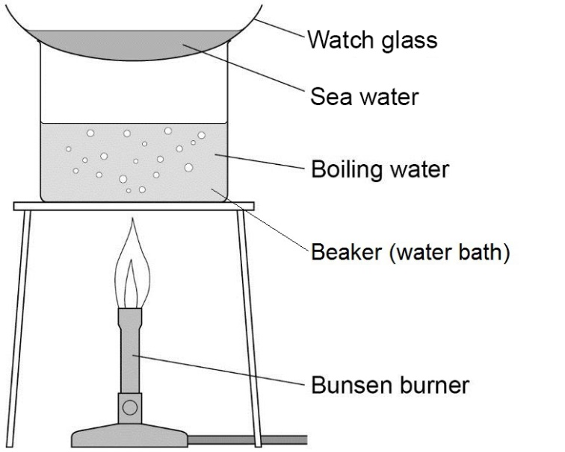
- Weigh a dry watch glass. Record its mass in the into it and place it above a beaker acting as a water bath as shown in the diagram.
3. Allow all the water to evaporate from the watch glass. Do not let the water bath boil dry.

4. You should see dissolved solids on the glass. Remove the watch glass with tongs and allow to cool. Dry the bottom of the watch glass with a cloth and reweigh it. Record the new mass in the table. Subtract the mass of the watch glass alone and record the mass of the dissolved solids. Wash the watch glass and dry it.
- Repeat steps 2 – 4 for the other water samples. You do not need to weigh the empty watch glass again as long as you use the same one each time.
Place the remaining sea water (around 40 cm³) in the conical flask and set up the apparatus for
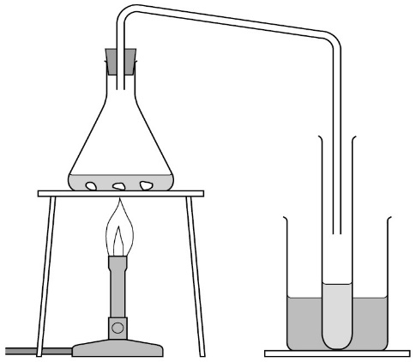
distillation as shown in the diagram.
- Make sure the conical flask is held on the tripod and gauze using the clamp stand. Place a mixture of ice and water in the beaker surrounding the test tube.
- Heat the sea water with the Bunsen burner until it starts to boil. Then reduce the heat so that the water boils gently. Distilled water will collect in the cooled test tube. Collect about 5 cm depth of water in this way, then stop heating.

- Repeat the tests in steps 1 to 4 again using the distilled sea water, again recording your results in the table. How does the distilled water compare with the undistilled sea water?

Water | pH | Mass in grams
 |  | Watch glass | Watch glass and dissolved solids | Dissolved solids
Sea
Spring
Rain
Distilled sea

Check up:
- Look at the learning outcomes. Highlight the text where each learning outcome is achieved during in the experiment.

- What hazards are there in following this procedure and how do you minimise the risk?

