Physics Revision: Nuclear Fission
Mastery Matrix Points TRIPLE ONLY
Explain the process nuclear fission (triple)
Explain chain reactions and how they are caused (triple)
Explain the process of nuclear fusion (triple)
Explain the conditions required for fusion (triple)

Key Knowledge

Definition for nuclear fission:

Definition for nuclear fusion:

Nuclear fission
Start with:

The products are:

Two uses:

Nuclear fusion
Start with:

The products are:

Where does this happen?

and Nuclear Fusion
Understanding and Explaining
- Describe the process of nuclear fission in detail including the products and type of energy made.

- Spontaneous fission is rare. Explain what is needed to start of a fission reaction.

- Explain how the products of a fission reaction can go on to cause chain reactions.

- Explain in sentences what is happening the fission reaction below.
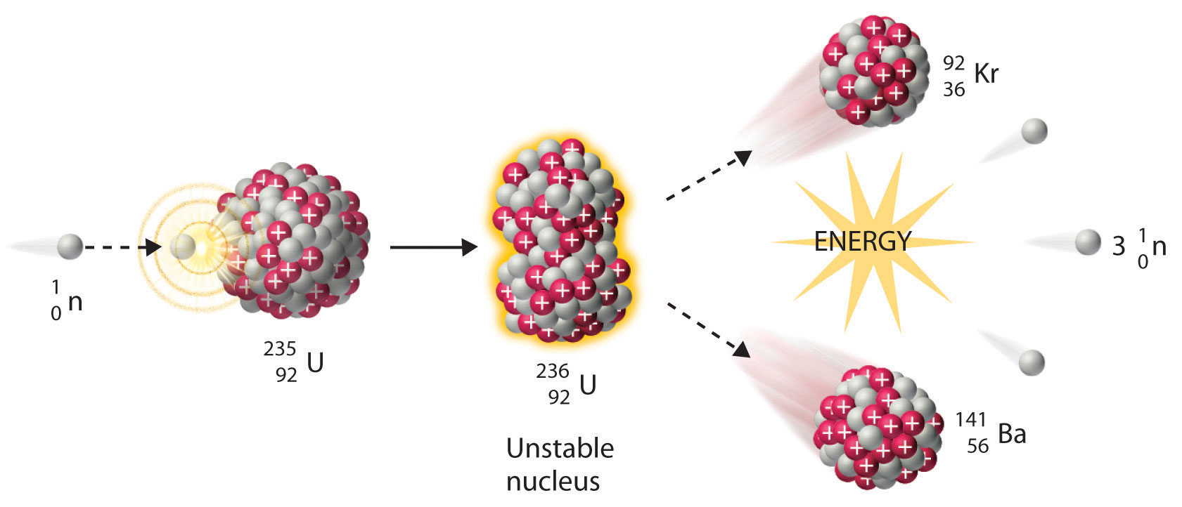
- Describe the process of nuclear fusion. Explain what is produced and where the energy comes from.

- Describe and explain the conditions needed for nuclear fusion to occur.

