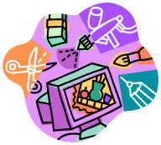

CHECKLIST TO EXAM SUCCESS- 40%


Graphics illustration
OBJ 1: Inspiration – researching artists/illustrators/designers 10%

Exam Objective | Evidence in sketchbook/folder | Tick
Researching ‘artists’ | Research of range of (4) artists.
Showing an understanding | Mood boards on selected artists-visual and written information or analysis.
Using inspiration from an ‘artist’ | Experimenting with images using ideas/style of artists.
Use of Cultural images, artefacts & symbols | If relevant research on ‘cultural’ images, signs and symbols Eg. African images, map design, London architecture
Idea development | Imaginative ideas combining images, artists styles and own creativity.

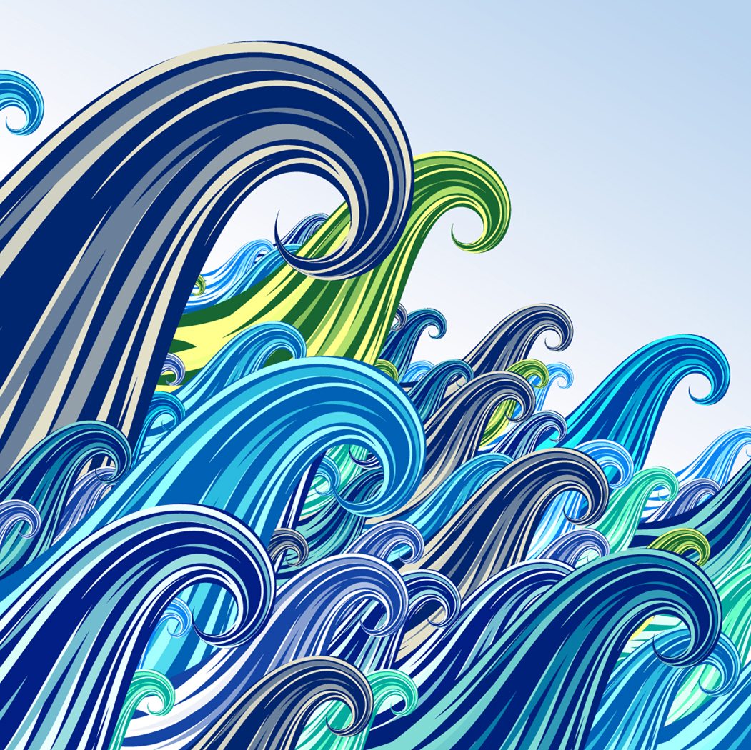


Artists
Designers
Cultures


OBJ 2: Refined ideas, media tests, thumbnails, final designs, final idea 10%
Exam Objective | Evidence in sketchbook/folder | Tick
Initial ideas | Thumbnail, collage or Photoshop ideas.
Developed ideas | Use thumbnails to plan out 3 creative ideas with sections in colour.
Experimentation | Testing out different colour ranges, artist styles and techniques on ideas.
Final design | Plan out/draw out full final design. Check design with teacher.
Final idea mood board | A2 design sheet showing inspiration, development and plan of final design with full test section using chosen media
Ideas, testing, final plan.

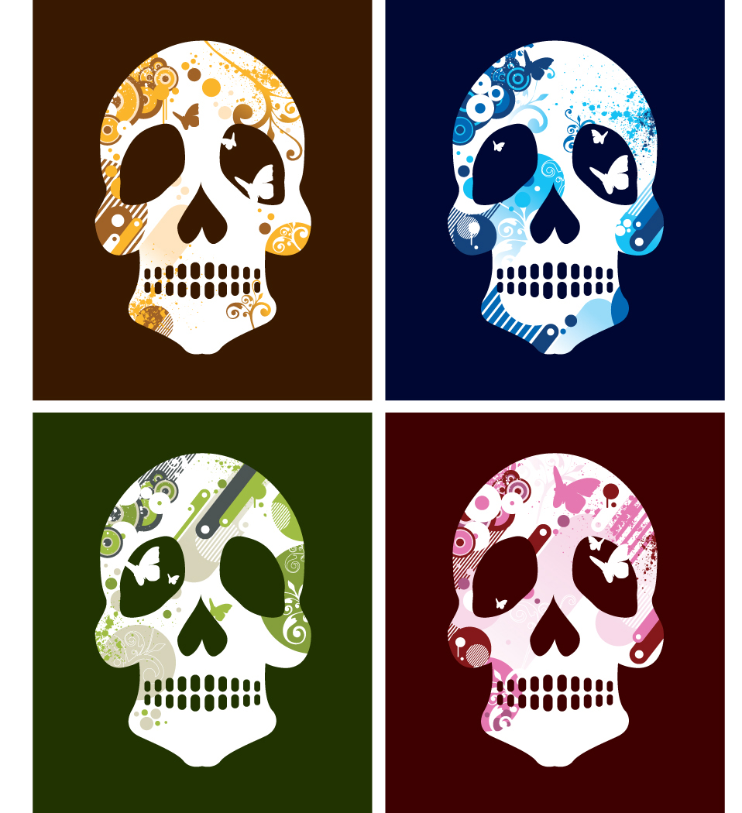

OBJ 3: Initial research, photos, drawings, observation, images 10%
Exam Objective | Evidence in sketchbook/folder | Tick
Effective image research | Use of internet, magazines, books for imagery.
Strong observation | One strong study. Lots of detailed drawings, sketches, experimental imagery. Can have own photos.
Experimenting with media | Creative testing with collage, acrylic, pastel, mixed media, Photoshop etc. Work to strengths.
Text ideas | Experimenting with fonts, styles if appropriate
Developed images/ideas | Testing images, colour, and techniques.

Images, photos, sketches,
Observation research.

OBJ 4: Final piece inspired by artist, illustrator or Graphics styles 10%

Exam Objective | Evidence | Tick
Organise equipment and materials | Check you have everything you need for the exam. Bring in sketchbook and all prep.
Plan out 10 hour exam | Plan out time frame for exam
Ensure quality final piece | Evaluate work as it progresses. Have you REFINED the piece using shading, fine detail, cross hatch, stipple in last 2 hours?
Produce a finished 10 hour exam piece | Decide on size of work you know you can complete in time. Check the observation of final piece. Is it ACCURATE & REFINED?

