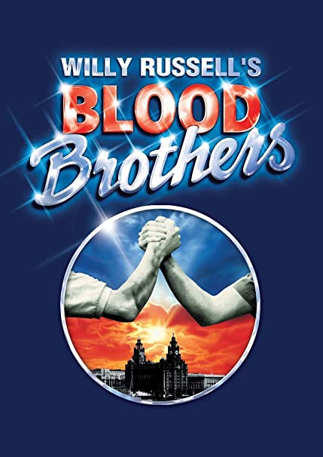

DRAMA REVISION BOOKLET

NAME: ____________________________________________________________________________
TEACHER: _________________________________________________________________________

Staging
- Label the different areas of a stage:

Audience

- Identify the following stage types:

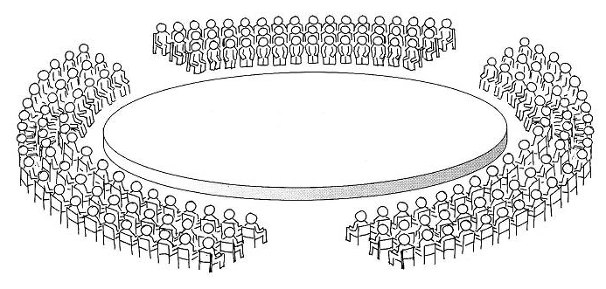
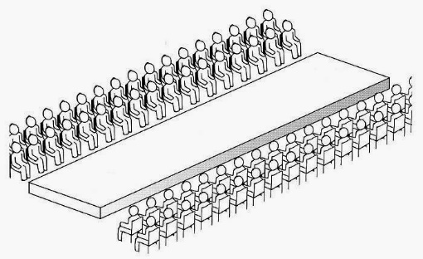

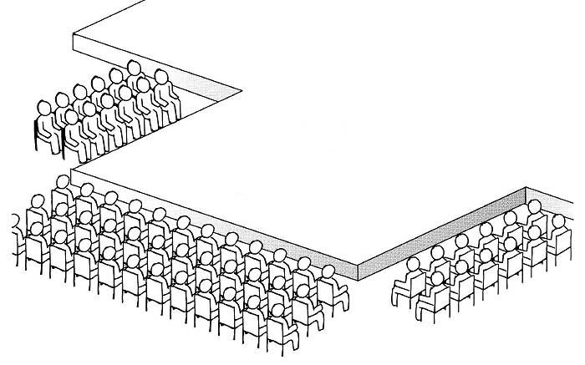
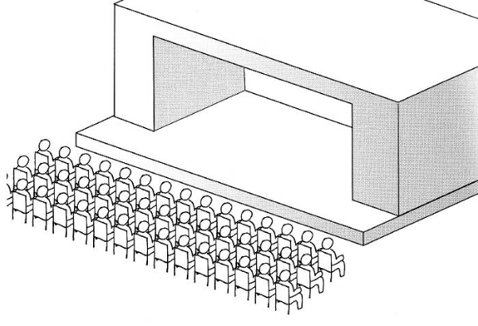

Lighting
- Identify the following lamps:

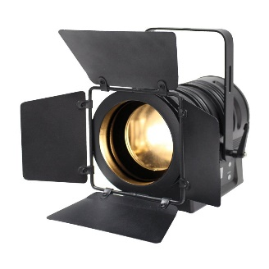
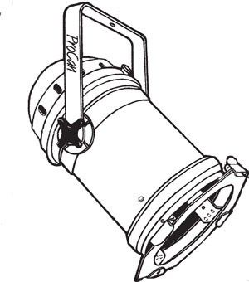

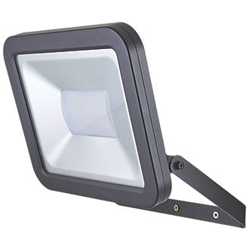
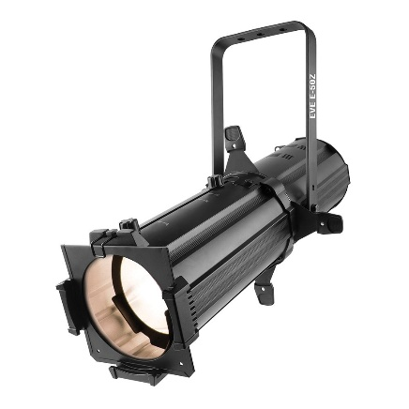

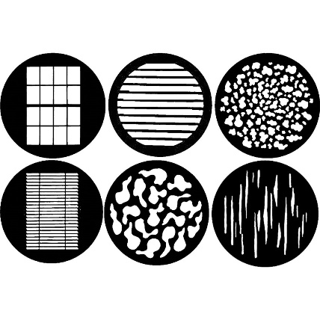

Set

- Identify the different set dressings:
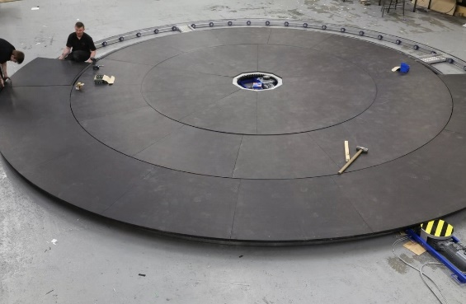
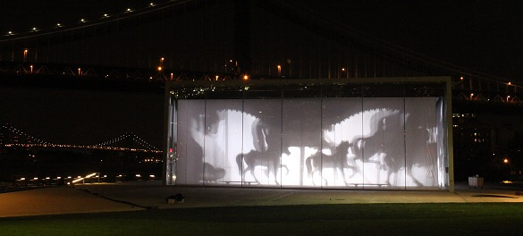

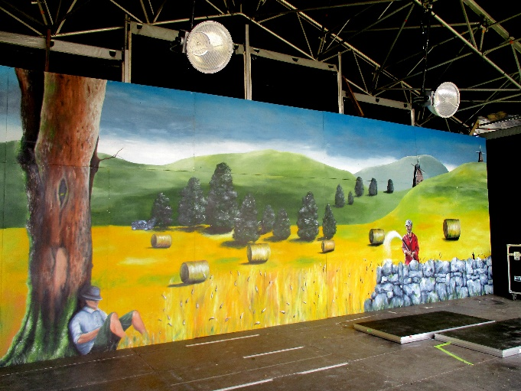
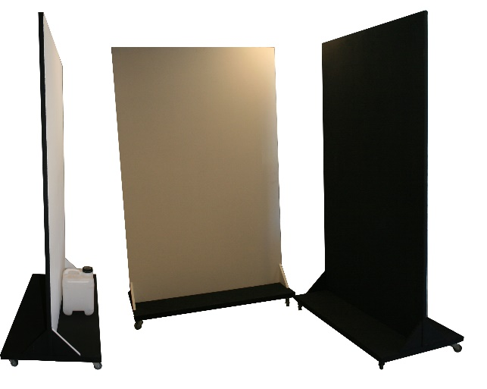

Be prepared to use as many of these in your design answers as you must be specific. Using theatrical terminology correctly will secure you more marks.
The more varied your design ideas, the better your response will be.

Performance Skills
- In the grid below, identify vocal skills and physical skills:
(You may want to use V and P or 2 different colours to highlight)

ACCENT | STRIDE | POINT | VOLUME
PITCH | SCREAM | ARTICULATION | GESTURE
RUN | GAIT | PACE (Speed) | PACE (Walk)
EMPHASIS | CRAWL | SHIVER | WHISPER
LAUGH | FREEZE | STUTTER | CRY
WHISTLE | FURROWED BROW | STARE | BLINK
TONE | ISOLATE | STAND UPRIGHT | TUT
WIDE-EYED | SLOUCH | SCOFF | BARK

When you are explaining how you, or your performer, would deliver a specific line from the text, you MUST use specific vocal and physical skills (like the ones above). Please refer back to this when you are answering a director or performer question.

The following page features an extract from Blood Brothers. It is taken from Act 2 in the chambers when Mickey confronts Edward before the shooting.

TASK: Read the extract and begin to consider how you, as a director, designer and performer, would bring this scene to life. You should annotate the extract with ideas as you go through.

From Act Two
Edward: And if, for once, I agree with Councillor Smith, you mustn’t hold that against me. But in this particular instance, yes, I do agree with him. You’re right, Bob, there is a light at the end of the tunnel. Quite right. None of us would argue with you on that score. But what we would question is this, how many of us…
(From his audience a commotion beginning. He thinks he is being heckled and so tries to carry on. In fact his audience is reacting to the sight of Mickey appearing from the stalls, a gun held two-handed, to steady his shaking hands, and pointed directly at Edward. Edward turns and sees Mickey as someone on the platform next to him realises the reality of the situation and screams.)
Mickey: Stay where you are!
(Mickey stops a couple of yards from Edward. He’s unsteady and breathing awkwardly.)
Edward: (eventually) Hello, Mickey.
Mickey: I stopped takin’ the pills.
Edward: (pause) Oh.
Mickey: (eventually) I began thinkin’ again. Y’see. (To the councillors.) Just get her out of here, mister, now!
(The councillors hurry off. Edward and Mickey are now alone on the platform.)
Mickey: I had to start thinkin’ again. Because there was one thing left in my life. (Pause) Just one thing I had left, Eddie – Linda – an’ I wanted to keep her. So, so I stopped takin’ the pills. But it was too late. D’ y’ know who told me about…you…an’ Linda…your mother…she came to the factory and told me.
Edward: Mickey, I don’t know what she told you, but Linda and I are just friends…
Mickey: (shouting for the first time) Friends! I could kill you. We were friends, weren’t we? Blood brothers, wasn’t it? Remember?
Edward: Yes, Mickey, I remember.
Mickey: Well, how come you got everything…an’ I got nothin’? (Pause.) Friends. I’ve been thinkin’ again, Eddie. You an’ Linda were friends when she first got pregnant, weren’t y’?
Edward: Mickey!
Mickey: Does my child belong to you as well as everythin’ else? Does she, Eddie, does she?
Edward: (shouting) No, for God’s sake!
(Pause. From the back of the auditorium we hear a Policeman through a loudhailer.)
Policeman 1: Now listen, son, listen to me, I’ve got armed marksmen with me. But if you do exactly as I say we won’t need to use them, will we? Now look, Michael, put down the gun, just put the gun down, son.
Mickey: (dismissing their presence) What am I doin’ here, Eddie? I thought I was gonna shoot y’. But I can’t even do that. I don’t even know if the thing’s loaded.
TASK: You are designing a costume for Mickey to wear in a performance of this extract.
The costume must reflect the context of Blood Brothers, set in a working-class Liverpudlian community in the early 1980s. Describe your design ideas for the costume. [4 marks]
Style:
Formal clothing | Uniformed clothing | Expensive clothing
Casual clothing | Threadbare clothing | Brand new clothing

Material:
Cotton | Polyester | Velvet
Leather | Suede | Denim

Specific items:
Shoes/trainers | Tracksuit | Trousers
Shorts | Shirt | Jumper
T-Shirt | Hoodie | Coat

Additional items:
Jewellery | Hat/cap | Glasses
Umbrella | Bag | Football scarf

Remember, your choices must show that you have a clear understanding of the character of Mickey. Think about his background; his current financial and social situation; personal hygiene; his concern of what others may think of him and his appearance.
Also consider the time period. In this scene it is the 1980s.

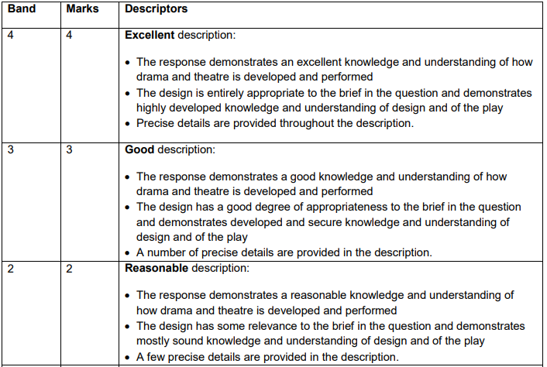

Example:
As a designer, designing the costume for Mickey in this scene I would want to show the audience his working class background having him appear in very casual clothing. I would look to having him wear distressed jeans that are well-worn and grimy, demonstrating his lack of money to buy new clothes and the fact that he does not really care about his appearance.
I would teem his jeans with a basic white cotton t-shirt that is representative of basic fashion in the 1980s and again demonstrates he is far from interested in wearing flashy clothing in an effort to simply blend in.
At this point in the play Mickey’s mental health has deteriorated and seems to be giving up and this would be reflected in his hair being messy and unkempt as I would want the audience to understand that Mickey is having a very difficult time and these costume choices allow them to understand this simply.

TASK: Can you identify the WHAT/HOW/WHY in the example? Highlight them.
WHAT (What is the designer – you – trying to to show about Mickey/Liverpool/the era?)

HOW (Which specific design elements are you using? You must use specific ideas with terminology)

WHY (Why are these ideas important for your audience? What do you want them to see/think/feel?)

TASK: Answer the 4-mark question using the notes and example above:

TASK: Self-assess your answer. Use the mark scheme; compare it to the example and your initial ideas. What worked well? How would you improve it? What mark would you award yourself?

WWW:

EBI:

MARK:
TASK: You are performing the role of Edward.
Describe how you would use your vocal and physical skills to perform the line below and explain the effects you want to create.

‘Mickey, I don’t know what she told you, but Linda and I are just friends...’ [8 marks]

Remember the WHAT/HOW/WHY structure:
WHAT do you want to show about Edward; his feelings about Mickey; his feelings about Linda?
HOW are you going to deliver this line using SPECIFIC vocal AND physical skills?
WHY are your choices going to be effective for your audience? What will they think/feel towards Edward? How do they link to your aims?

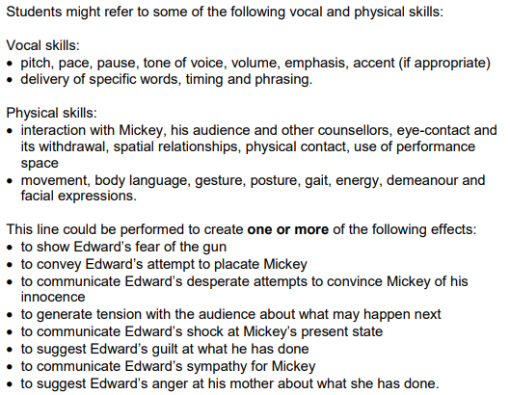

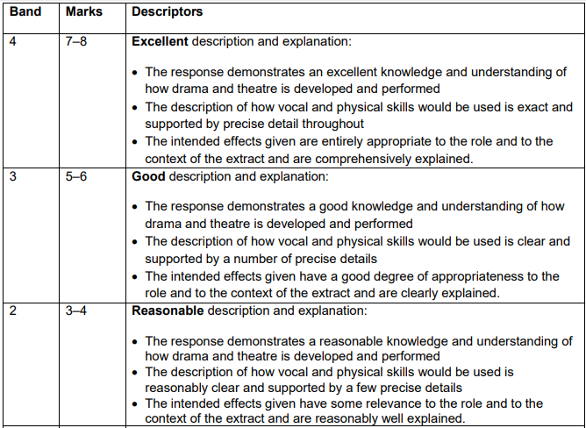

Example:
As a performer playing the role of Edward my main objective will be to calm Mickey down and stop him from doing something silly. I would want him to see I was no threat by holding both hands up, palms out towards him. I would hold my shoulders back in an effort to try and remain calm and stifle my fear.
When I say ‘Mickey’ I would use a reduced volume, again to maintain calm, and use a calm and measured tone to try to show him that nothing has changed between us. This would encourage the audience to see that I have Mickey’s best interests at heart. I would purposely pause before I say ‘I don’t know what she told you’ with a slow pace in order to make sure I am speaking clearly and Mickey hears every word. I would also purposely make no effort to move, instead staying completely still and keep the distance between me and Mickey. Again, I would want the audience to see that I am trying to placate Mickey and keep the scene as calm as possible.
When I deliver the final part of the line I would emphasise the words ‘just’ and ‘friends’, to convince not just Mickey but the audience too. I would widen my eyes at this point and have my mouth remain open as if to say something else but quickly thinking better of it. This would show my nervousness at the situation and the audience would see how difficult this is for both of us.

TASK: Highlight the WHAT/HOW/WHY in the example.

TASK: Answer the 8-mark question using the guidance above.

TASK: Self-assess your answer. Use the mark scheme; compare it to the example and your initial ideas. What worked well? How would you improve it? What mark would you award yourself?

WWW:

EBI:

MARK:
TASK: You are a designer working on one aspect of design for this extract.
Describe how you would use your design skills to create effects which support the action.
Explain why your ideas are appropriate for:
• this extract
• your chosen design skill in the play as a whole. [20 marks]

Consider the ONE of the following:

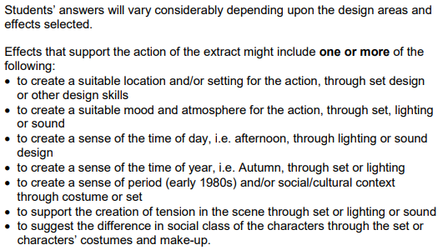

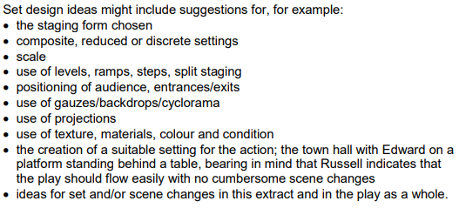

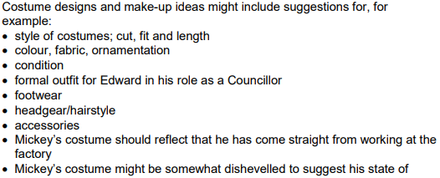

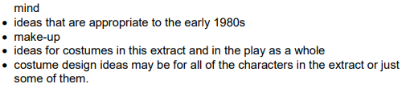

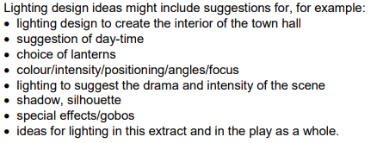

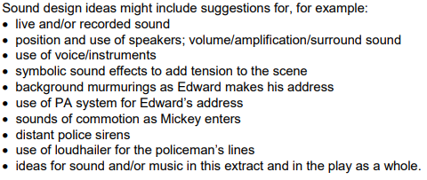

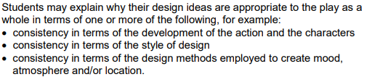

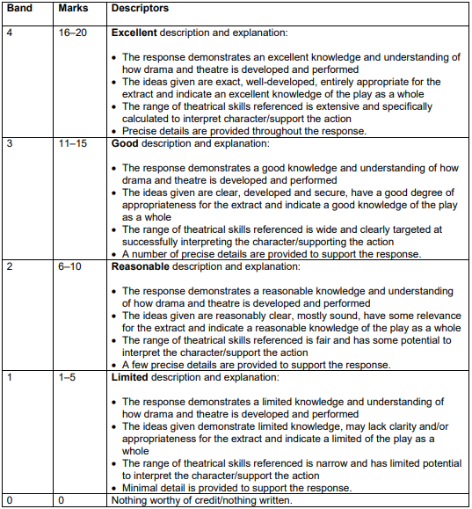

TASK: Self-assess your answer. Use the mark scheme; compare it to the example and your initial ideas. What worked well? How would you improve it? What mark would you award yourself?

WWW:

EBI:

MARK:

